CHAPTER IV

PROJECT TECHNICALITY

This chapter discusses the system project scope that help the users know the limitations of the system, usage scenario which display the use case that designates the interaction of the system and users or the actors. It also includes the major software functions, performance issues and management of the system – used to resolve some issues regarding the implementation of the system. Moreover, the different modules, storage design, and the software interface descriptions are elaborated in the succeeding sections.

4.1 System Project Scope

The Inter-Pacific Study and Migration Consultancy Information System (IPSMCIS) is a web-based system. The primary aim of the system is to make the organization transactions easier and faster by automating their manual process regarding the application for tourist and student visa, matching of student and tourist, and monitoring student status abroad. By the use of the proposed system, it helps the organization to transfer information to and from the school.

4.2 Usage Scenario

The Use Case Model described the functionality of the Inter-Pacific Study and Migration Consultancy. Each use case represents an interaction between the user and the system. The entire scenario in the system is represented in this model. This model is drawn to capture or gather the functional requirements of a system which includes the internal and external entities.

There are different use cases which are the creates student and tourist profile, updates student and tourist profile, view student and tourist profile, generate reports, view IELTS exam schedule, view IELTS review schedule, and monitors student. Each of the use case is assigned to different users which are the student, tourist, and consultant. These users are necessary so that the system could work its purpose.

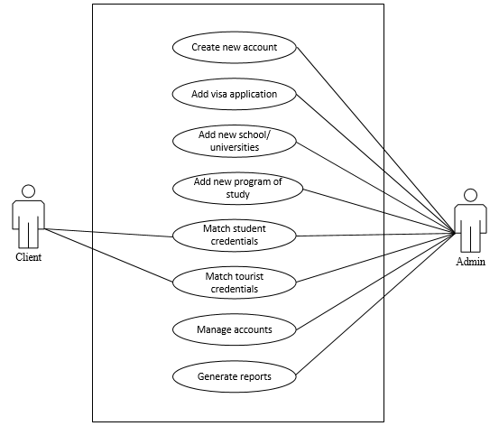

Figure 21. Use Case Diagram of Inter-Pacific Study and Migration Consultancy

Information System.

Table 9 shows how the user creates their account to access the system. Every client must have their own account and exact information about him/ her so that the administrator recognized and identify them properly.

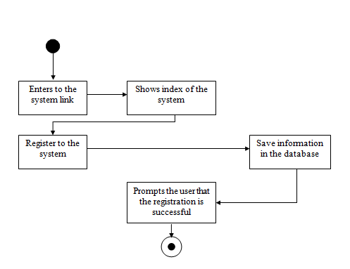

|  |  |  |
| --- | --- | --- |
| Use Case Name | Create new account | |
| Use Case Description | This table show the step by step process on how the user create their own account in the system. | |
| Precondition | * Users must know the exact information to be input in the system. | |
| Post Condition | * Users access the system. * Users use the different modules in the system. | |
| Activity Flow | | |
| Users | System | Database |
|  |  |  |
| Alternate Flow | * Add new user using the database. | |
| Exception Flow | * If there is no connection the user cannot create an account. * Data exist * If there is missing field data not be saved. | |

Table 9. Create new account.

Table 10 shows the step by step process on how the administrator create a visa application for the client who wants to apply for their visa. It also help other user by following the flow that shown in the table from beginning to the end.

|  |  |  |
| --- | --- | --- |
| Use Case Name | Add visa application | |
| Use Case Description | This table show the step by step process on how the admin create a visa application for the client that want to apply for visa application. | |
| Precondition | * Users must have an account in the system. * Clients must complete the requirements required. | |
| Post Condition | * Clients use the matching features. * Clients manage their profile. | |
| Activity Flow | | |
| Users | System | Database |
|  |  |  |
| Alternate Flow | * Add new entry using the database. | |
| Exception Flow | * The character that has been input is unrecognized by the system. * There is no internet connection. * If there is missing field data not be saved. * Data exist. | |

Table 10. Add visa application.

Table 11 shows the step by step process on how the administrator add a new school with their specific information. This data is used for matching purposes. After adding those data, it automatically show in the list tab together with its information.

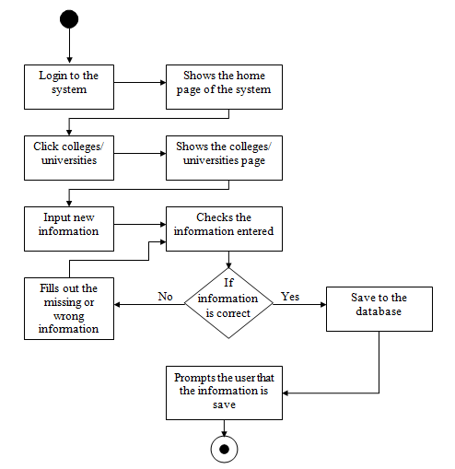

|  |  |  |
| --- | --- | --- |
| Use Case Name | Add new school/ universities | |
| Use Case Description | This table show the step by step process on how the admin add a new record of school with specific information in the system. | |
| Precondition | * Users must have an account in the system. * Users must have a exact information about the school. | |
| Post Condition | * Clients use the added school for matching purposes. | |
| Activity Flow | | |
| Users | System | Database |
|  |  |  |
| Alternate Flow | * Add new school using the database. | |
| Exception Flow | * The data exist. * There is no internet connection. * If there is missing field data not be saved. | |

Table 11. Add new school/ universities.

Table 12 shows the step by step process on how the admin add a new program with their specific information. This data is used for matching purposes. After adding those data, it automatically show in the list tab together with its information.

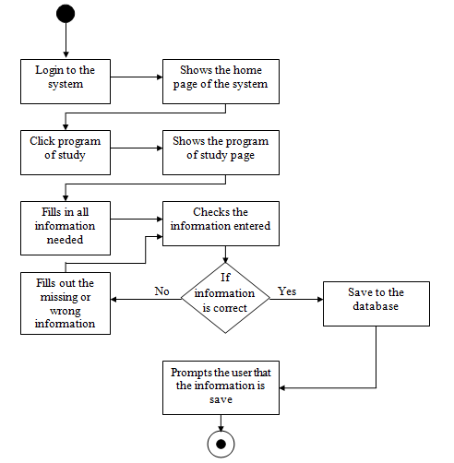

|  |  |  |
| --- | --- | --- |
| Use Case Name | Add new program of study | |
| Use Case Description | This table show the step by step process on how the admin add a new record of programs in different school in the system. | |
| Precondition | * Users must have an account in the system. * Users must have a exact information about the program. | |
| Post Condition | * Clients use the added program for matching purposes. | |
| Activity Flow | | |
| Users | System | Database |
|  |  |  |
| Alternate Flow | * Add new program using the database. | |
| Exception Flow | * The data exist. * There is no internet connection. * If there is missing field data not be saved. | |

Table 12. Add new program of study.

Table 13 shows the process on how the client execute the matching feature of the system. This process help the client (student) find a suitable course that he/ she wants to enroll. Once the client finish selecting the data. Those data that been selected was saved in the database.

|  |  |  |
| --- | --- | --- |
| Use Case Name | Match student credentials | |
| Use Case Description | This table show the step by step process on how the client find a school that has a program that he/ she wants to enroll. | |
| Precondition | * Users must have an account in the system. * Clients must complete the requirements required. | |
| Post Condition | * Clients decide the preferred course that they want to enroll. | |
| Activity Flow | | |
| Users | System | Database |
|  |  |  |
| Alternate Flow | * No alternate flow. | |
| Exception Flow | * If there is no internet connection. | |

Table 13. Match student credentials.

Table 14 shows the process on how the client execute the matching feature of the system. This process help the client (tourist) find a spot location that he/ she wants to visit. Once the client finish selecting the data. Those data that been selected was saved in the database.

|  |  |  |
| --- | --- | --- |
| Use Case Name | Match tourist credentials | |
| Use Case Description | This table show the step by step process on how the client find a travel spot in a specific country that he/ she wants to visit. | |
| Precondition | * Users must have an account in the system. * Clients must complete the requirements required. | |
| Post Condition | * Clients decide the preferred travel spot that they want to visit. | |
| Activity Flow | | |
| Users | System | Database |
|  |  |  |
| Alternate Flow | * No alternate flow. | |
| Exception Flow | * If there is no internet connection. | |

Table 14. Match tourist credentials.

Table 15 shows the process on how the admin execute the enable and disabling user in the system. This step by step process help the admin disable the user if this user is not active in the company.

|  |  |  |
| --- | --- | --- |
| Use Case Name | Manage accounts | |
| Use Case Description | This table show the step by step process on how the admin enable or disable the user in accessing the system. | |
| Precondition | * User must have an account in the system. | |
| Post Condition | * Client cannot log-in in the system if the account was disable by the admin. | |
| Activity Flow | | |
| Users | System | Database |
|  |  |  |
| Alternate Flow | * No alternate flow. | |
| Exception Flow | * If there is no internet connection. | |

Table 15. Manage accounts.

Table 16 shows the process on how the admin execute the generation of reports in the system. This step by step process help the administrator if what report she wants to show in the system and this report are shown in statistical graph format and it also printable, so that they have a hard copy of it

|  |  |  |
| --- | --- | --- |
| Use Case Name | Generate report | |
| Use Case Description | This table show the step by step process on how the admin generates different reports to be shown in the system. | |
| Precondition | * User must have an account in the system. * System must have the different data for the reports. | |
| Post Condition | * It show different statistical report. | |
| Activity Flow | | |
| Users | System | Database |
|  |  |  |
| Alternate Flow | * No alternate flow. | |
| Exception Flow | * If there is no data, it cannot generate report. * If there is no internet connection. | |

Table 16. Generate report.

4.3 Major Software Function

The Inter-Pacific Study and Migration Consultancy Information System has five modules. These five modules be the dashboard, visa application, list, matching, monitoring, and reports.

The decomposition chart of the system shows the breakdown of the modules and organizing them in the way that user login, input, transaction or processes, and output are specified each from the other.

Inter-Pacific Study and Migration Consultancy Information System

Matching

Entries

Log-in

Reports

Maintenance

Import

Monitoring

Student

Student Application

Program of Study

Colleges / Universities

Applicant Information Sheet

Number of Registered Applicants

Student

Dashboard

Export

Number of School per Country

Tourist

Activity Log

Frequently Selected Countries

User

Files

Visa Status

No. of Student and tourist per Country

Student Detailed Reports

Tourist Detailed Reports

Summary Report

Figure 22. Decomposition Chart of Inter-Pacific Study and Migration Consultancy Information System.

4.4 Performance Issue and Management of Technical Constraints

This section of the chapter discusses the constraints that affect the way the project be conducted. As the team starts the development of the proposed system, there are some issues that hamper the completion of the study. Some of the factors that could affect the project are the following issues: lack of financial assistance to support the implementation of the system, gathering of the enough data that be needed in the system, and any possible risk that might occur.

Regarding hardware, the team requires a simple computer set that is in good condition so that it could cater well the system that the team install. With the use of throwaway prototyping method, the team have a schedule for the activities weekly that would direct towards the completion of the system.

4.5 Modules Description

A module is a component of a program. Programs are composed of one or more individually developed modules that are not cumulated until the program is linked. A single module contain one or several routines. The following are modules that be included in the team’s system or program:

4.5.1 Dashboard – this module show the number of client every month and it is represented by a graph. This presentation of graph is filtered by year so that the number of client in past years also presented. Lastly, below the graph shows the top 5 rankings based on the number of client per countries, famous school, and in demand course.

4.5.2 Entries – this module has three sub modules which includes the: Visa Application, College/Universities, and Program of Study. Those module is used for encoding the important information of clients, schools, and program of study. Some of the data that been encoded is used in communicating school representative and also to their client.

4.5.3 Matching – this module has four sub modules which includes the: Users, which shows the list of all users; Student/Tourist, which shows the list of the students and tourist and the status of their visa; College/Universities, which shows the list of schools the organization is associated to; and lastly, program of study, which holds the list of the different set of programs offered by the school the organization is associated to.

4.5.4 Reports – this module generate useful reports needed by the organization. Those reports are represented in statistical graph and it is filtered by year. Those reports is also printable so that, they have a hard copy to present to their managing director.

4.5.5 Maintenance – this module is consist of import, export, and activity log. Import is use for importing the database in the system. Export is use for exporting the database. And the activity log is use to show those activities that done by the admin. Those activities has a date and time so that it track the latest activity done.

4.6 Software Interface Description

This section of the chapter covers the interfaces of the team’s system – Inter-Pacific Study and Migration Consultancy Information System (IPSMCIS). This section also discusses how the system operates using the interfaces.

Figure 23 is the Login/Register. Users who had already register to the system use their username and password to login in the site of the organization. Invalid username or password means that the user not be able to login and view the different features in the system.



Figure 23. Login Page.

Figure 24 is the Dashboard. Once the user or admin successfully logs in the Home be the next opening screen. In this interface, the different information seen in either graph, map, or text format. Users see information regarding the number of students that apply from that specific dates, top performing schools, and the most visited countries.

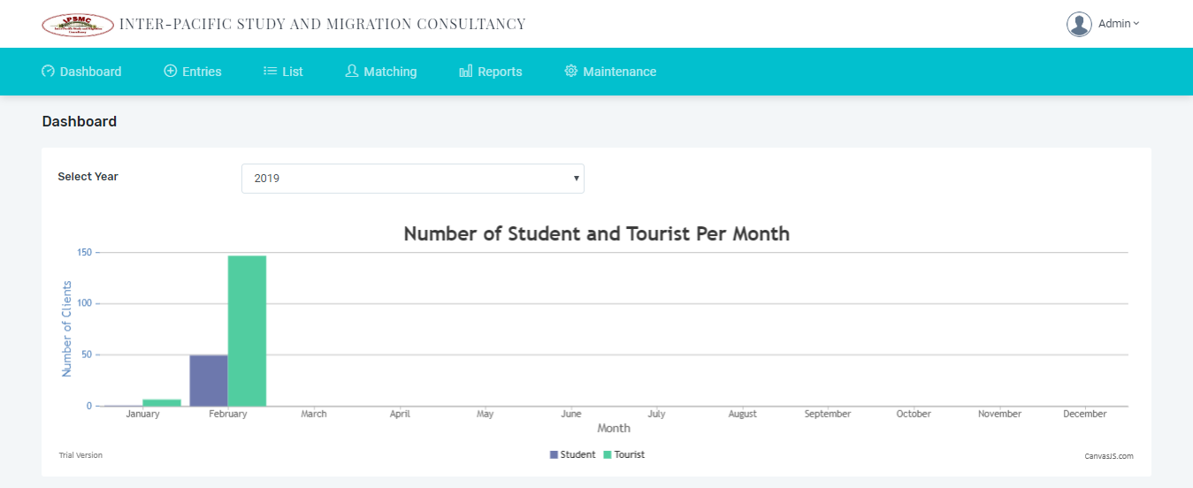

Figure 24. Dashboard.

Figure 25 is the visa application. This is the interface where the clients, either the student or the tourist supply the information needed and pass their requirements in a soft copy format. Important information be catered by this interface.

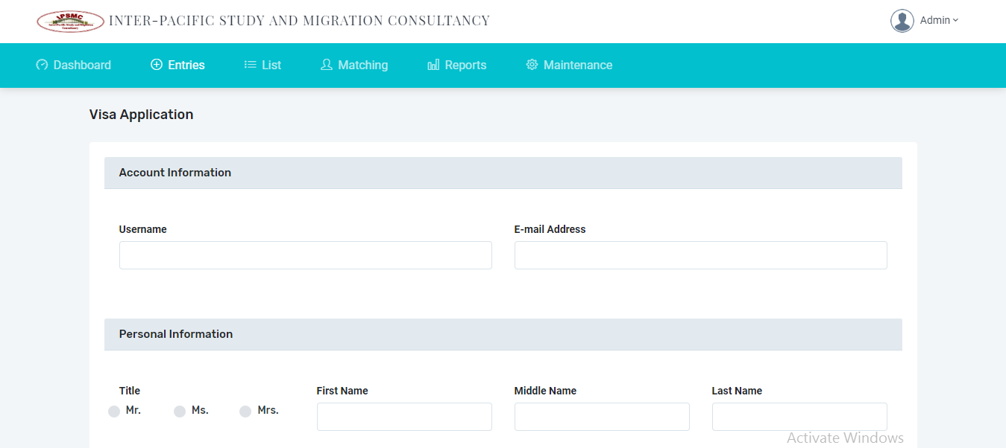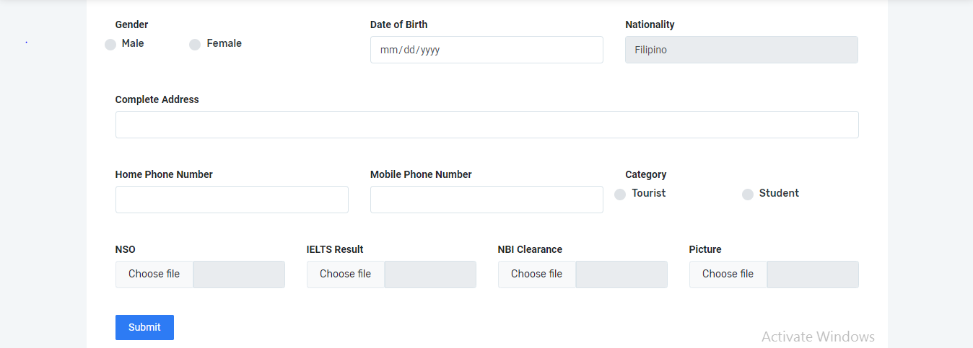

Figure 25. Visa Application.

Figure 26 is the School Application. Another tab under 'Entries' module is school application. This page is where the administrator of the company add the information of their partner schools and its representative. Some information that been encoded in this module is used for contact purposes.

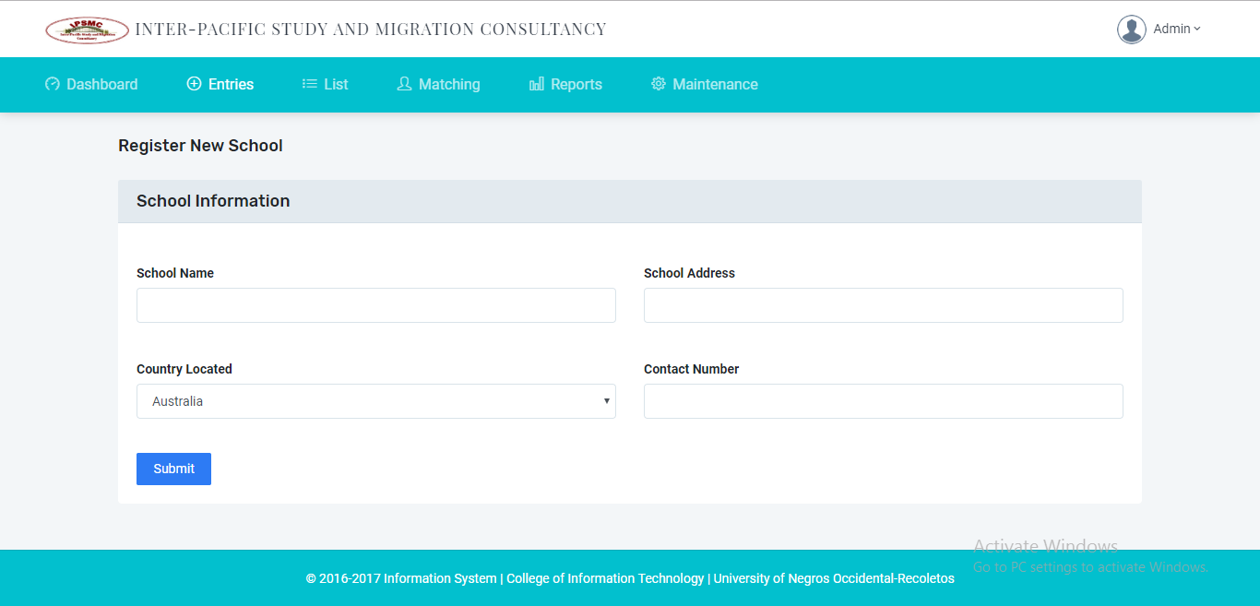

Figure 26. School Application.

Figure 27 is the program application. In this page, program of study or courses being offered by different partner schools are being input together with their estimated tuition fee for the whole year.

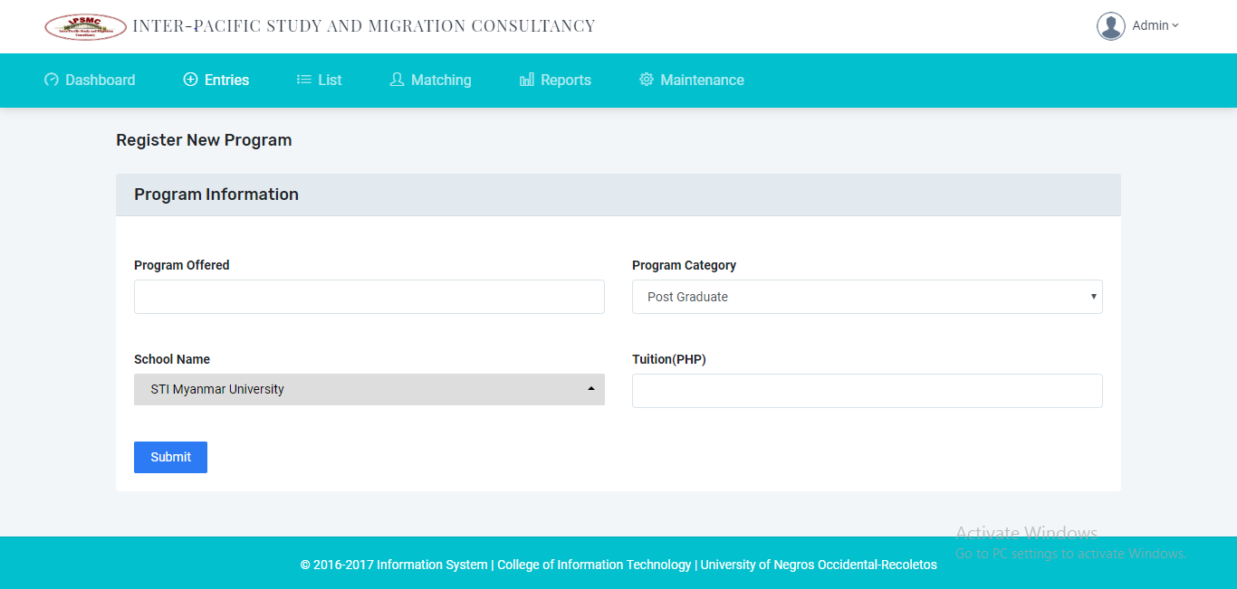

Figure 27. Program Application.

Next is the User List. In this page, the admin of the system see all the registered users of the system. The admin has a permission to disable a certain user if he or she is doing something inappropriate. It also has a notification message if the admin surely disable the client.

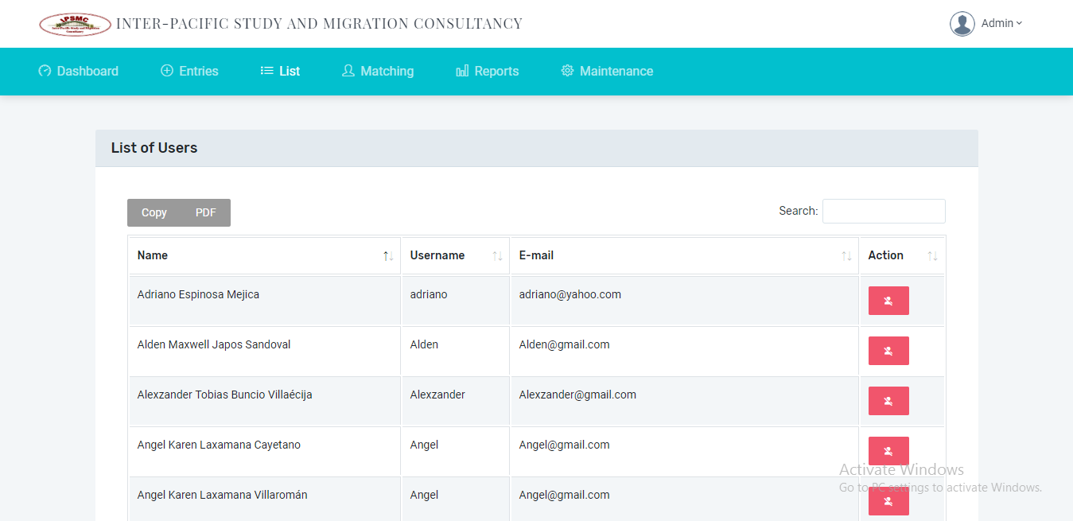

Figure 28. Users List.

Next is the Visa Application List. This page shows the list of all the visa applicants, whether they students or tourist. The admin of the system has a permission to change the visa status of a certain visa applicant if there is an update from the embassy.

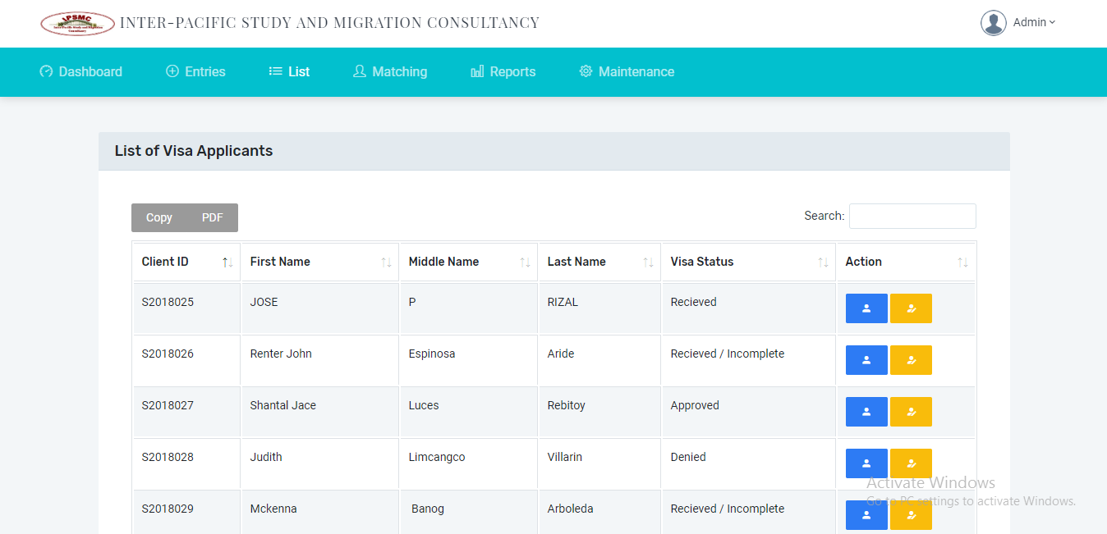

Figure 29. Student and Tourist List.

This next interface is the School List. In this page, all the schools or university being added on the school application tab is shown. The admin of the system can edit or update any information here if needed.

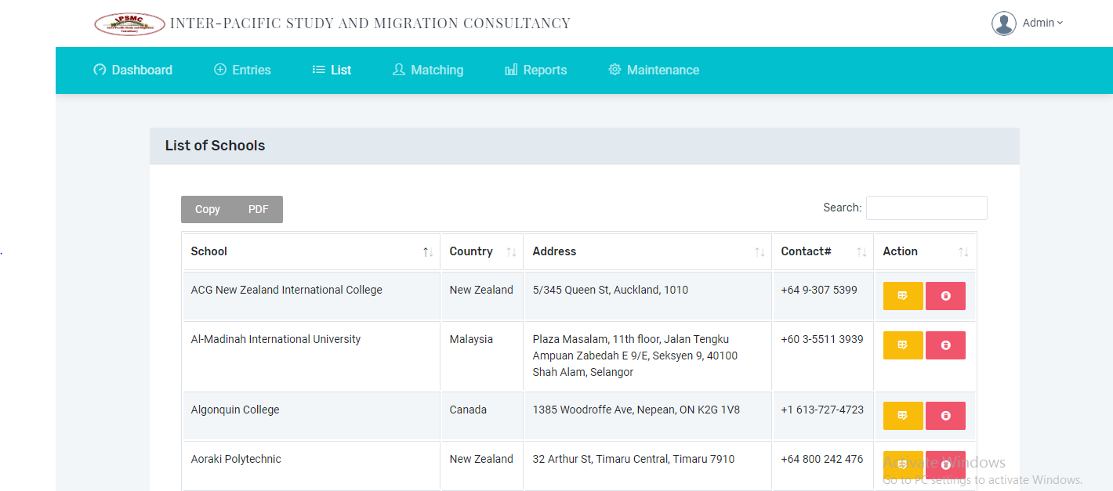

Figure 30. School List.

This next interface is the Program List. In this page, all the programs being added on the program application tab is shown. The admin of the system can edit or update any information here if needed.

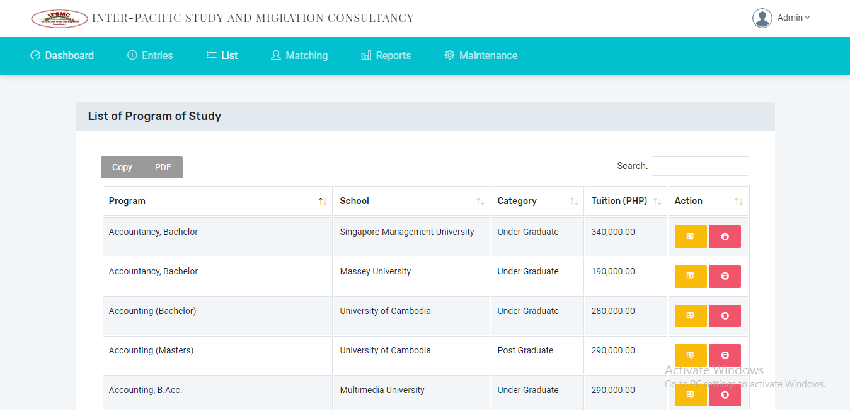

Figure 31. Program List.

This next interface is the Student Matching. In this module, the different student applicants match some information to find suitable school and course for them. This module also offers the student applicants easier way to find the school and course that they want with the given tuition.

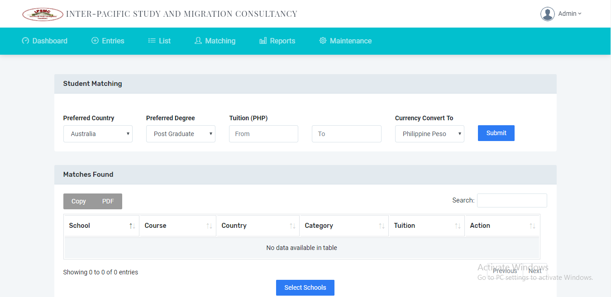

Figure 32. Student Matching.

This next interface is the Tourist Matching. In this module, the different tourist applicants match some information to find suitable spot for them. This module also offers tourist applicants easier way to find them a suitable destination within their budget.

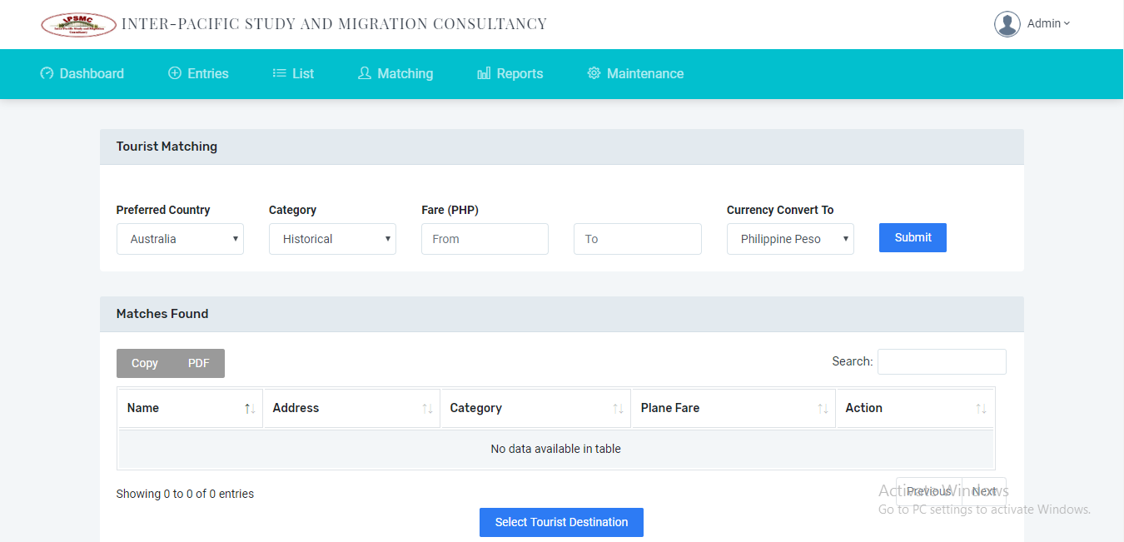

Figure 33. Tourist Matching.

This next interface is the Number of Registered Applicants Report. This module shows the number of registered applicants in the system. This report was filtered by year and at the left portion of the graph it shows the percentage number of both clients registered in the system.

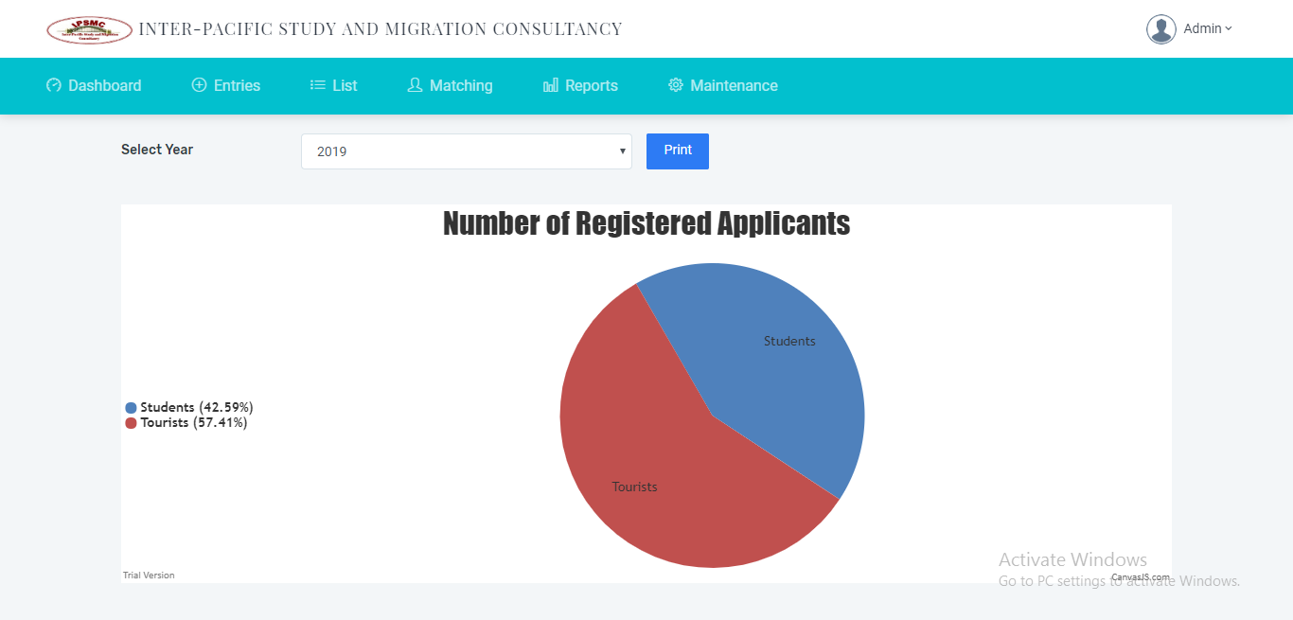

Figure 34. Number of Registered Applicants Report.

This next interface is the Number of Applied School per Country. This module shows the number of applied schools per country in the system. This report was filtered by year and the marker in the map shows the number of students in every country.

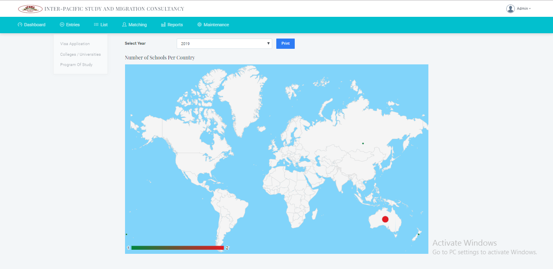

Figure 35. Number of Applied School Per Country Report.

This next interface is the Frequently Selected Country Report. This module shows the number of frequently selected country in the system. This report was filtered by year and the marker in the map shows the number of both clients in every country.

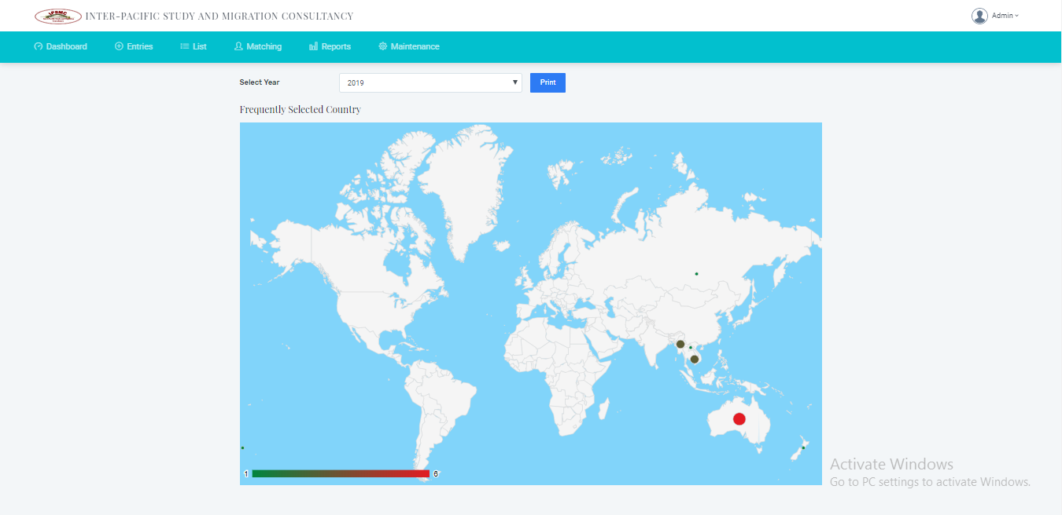

Figure 36. Frequently Selected Country Report.

This next interface is the Visa Status Report. This module shows the total client per visa status. This report was filtered by year and the different color shows the label of visa status of both clients in the system.

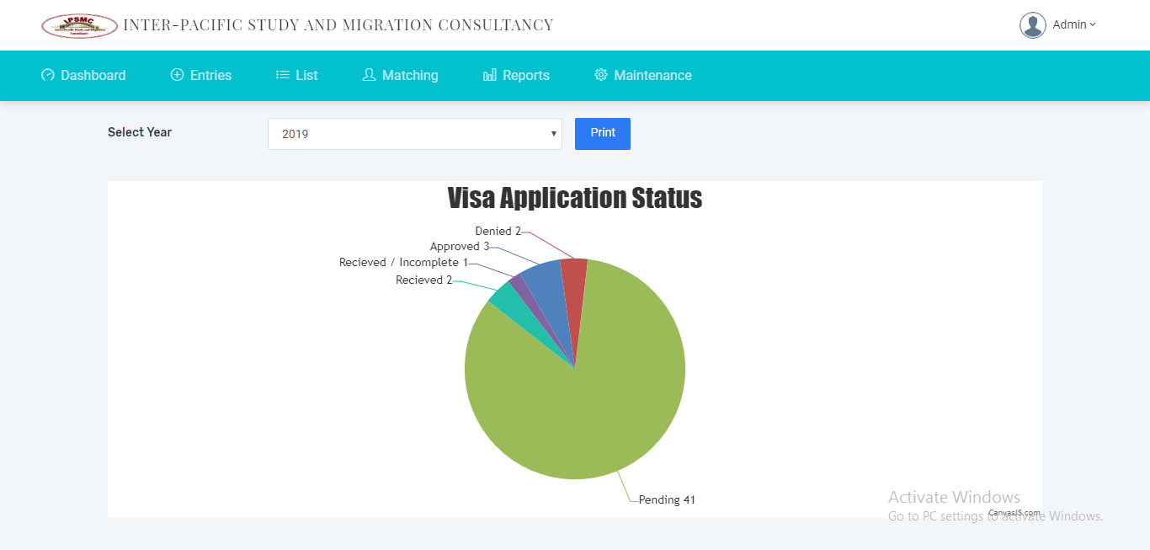

Figure 37. Visa Status Report.

This next interface is the Number of Student and Tourist Per Country Report. This module shows the total clients per visa country. This report was filtered by year and the two columns shows the number of clients in every country.

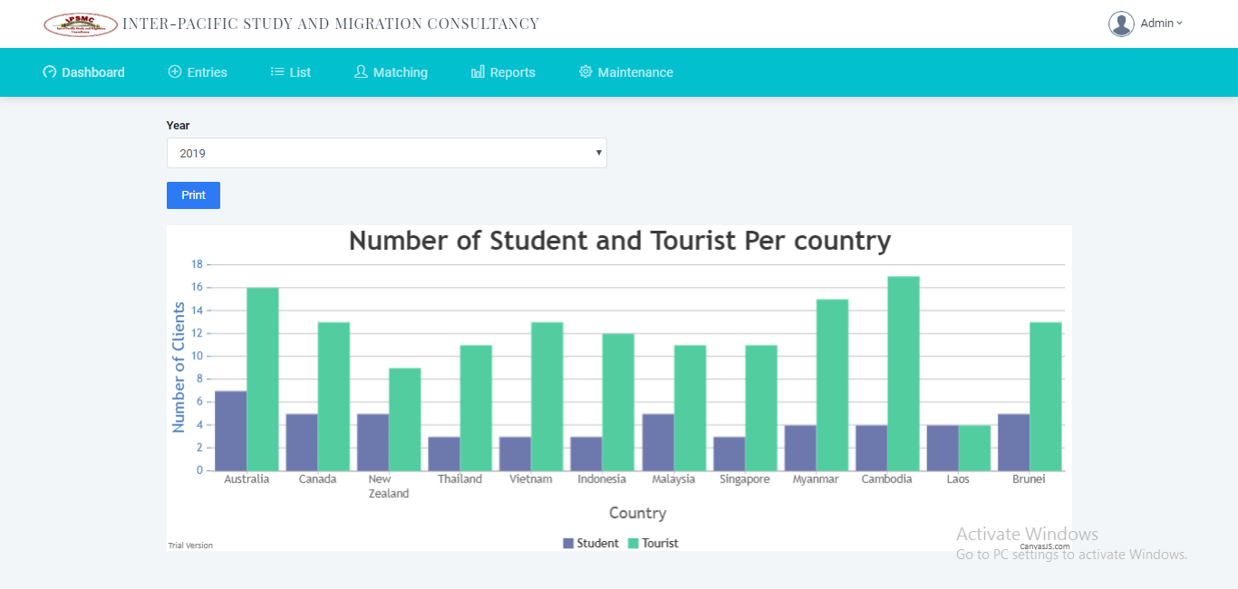

Figure 38. Number of Student and Tourist Per Country Report.

This next interface is the Student Detail Report. This report show the details of the student w/ picture and the chosen school w/ course detail that he wants to enroll. The picture below represents the print preview of student detail report.

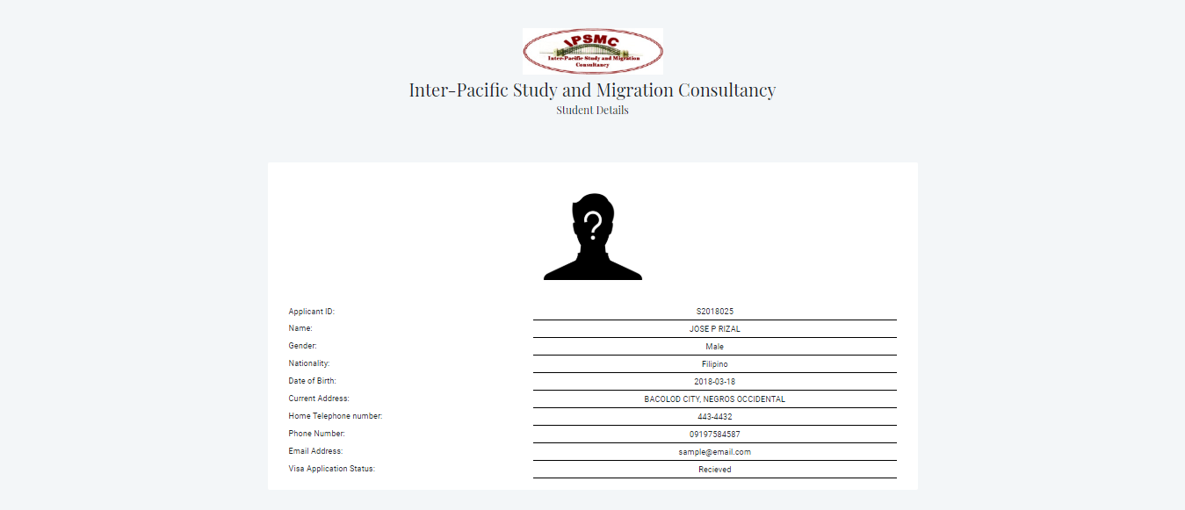

Figure 39. Student Detailed Report.

This next interface is the Tourist Detailed Report. This report show the details of the tourist w/ their picture and the chosen spots that he wants to visit. The picture below represents the print preview of student detail report.

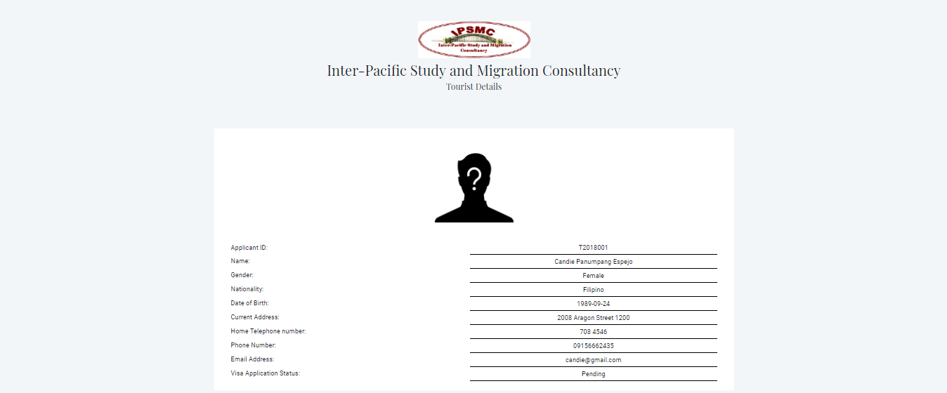

Figure 40. Tourist Detailed Report.

This next interface is the Summary Report. This module shows the different reports that been summarize in the system. This report was represented by graphical form. It was filtered by year, by status, by country, and by school.

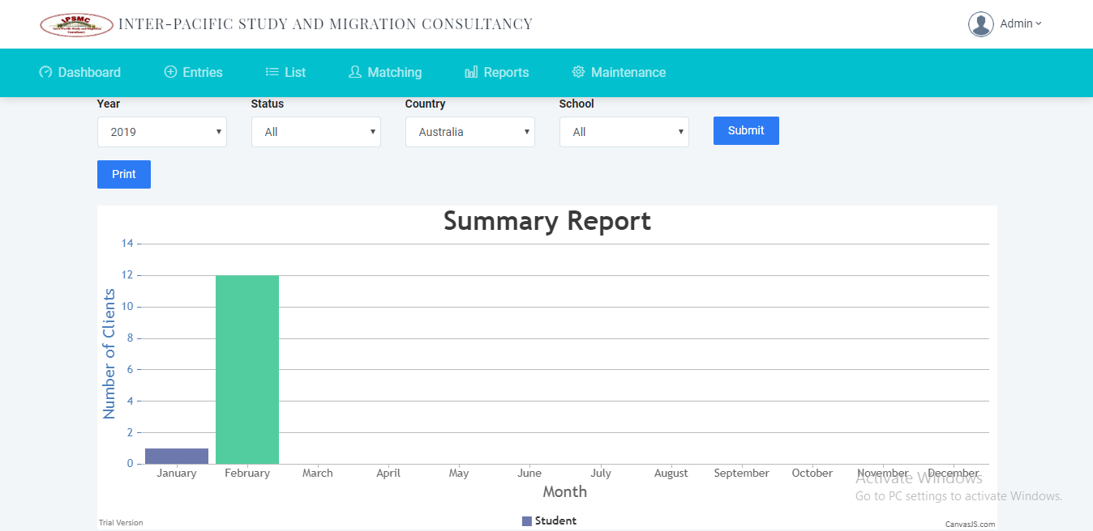

Figure 41. Summary Report.

The interfaces, system flow, and decomposition chart that have been discussed are the representations of the system. It is used as reference and guide during the whole planning and development phase of the system. Furthermore, this section also tackles about the usage scenarios and the capabilities of the user to the system. Every module has a description so that the readers know what the purpose of this module in the system.

The proponents conclude that the interfaces that shown in this chapter not the same to the interface that shown in the other browser. The use browser while getting the screenshot is Google Chrome, it is possible if it is open in the different browser it distort the interface.